
High Voltage ESC Power Supply

The HES ESC Power Supply is a high voltage system with floating bipolar
outputs capable of delivering up to 10kVDC (+/-5000V). The output polarity
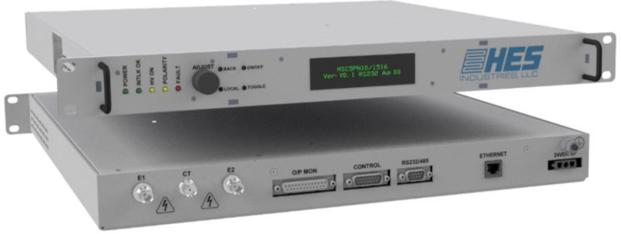
is reversible via the remote interfaces. It has a 3 pin TE MATE-N-LOK
non-reversible quick disconnect 24VDC input. SHV connectors are used
for the HV outputs, and an MHV for the center tap return.

The HES Power Supply is an ideal electrostatic
high voltage power supply designed to drive the electrodes of monopolar or bipolar, Coulomb and Johnsen Rahbek (JR) electrostatic chucks in a controllable rack mount package.



Features and Benefits

- Dual 0V to ±5kV DC bipolar outputs, at up to 2mA / 10 watts per output.
- Floating output return / center tap. Can be biased at up to ±250V DC.
- Programmable output offset voltages.
- Programable arbitrary de-chucking output waveforms to help minimize the difficulties in de-chucking substrates.
- Fast reversal of outputs via solid state switches with programable ramp rates.
- Solid state output voltage discharge clamps.
- Output polishing filters to help protect the unit against the effects of RF.
- Output voltage and current monitors.
- Floating output return / center tap voltage monitor.
- Output capacitance and resistance measurements.
- Wafer status detection with programmable capacitance or current thresholds.
- High precision, low ripple and noise outputs.
- Arc and short circuit protection.
- Remote control and monitoring via analog, RS232/485 and Ethernet interfaces.
- Local control and monitoring via front panel buttons, OLED display and LED indicators.
- 1U 19” rack mountable enclosure.
- Convection cooled.
- High reliability / MTBF
- Serial and Ethernet Communications GUI
Specifications

The unit meets the requirements of EN 61010-1, UL 61010A-1 and CAN/CSA-22.2 No. 1010.1 and is UL listed
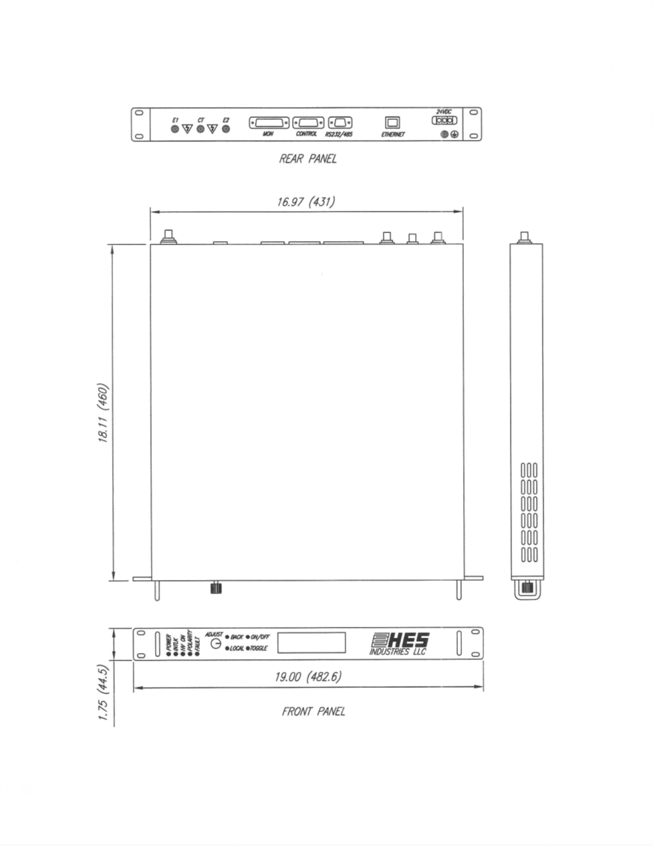
Please contact HES Industries high voltage sales for detailed product specification and quotation.

Custom High Voltage Cable Termination Options Available
Mechanical Details
HES Industries LLC Tel: (845) 897-1020
700 South Drive, Suite 104 email: john.miller@HybridESC.com Hopewell Junction, N.Y. 12533 www.HybridESC.com

